Reversing Anonymization

Design Description

Contents
High-level Description 3
Alter GENERAL_IMAGE table 3
Encryption Note 3
Alternate Schema 3
Storing Fields per Row of GENERAL_IMAGE 3
Add Data Migration Script 4
Update Database Adapter 4
Retrieval Queries 5
Decryption Tool 5
Test Approach 5

High-level Description
- Alter the database schema to include the new attributes.

- Add data migration script.

- Update the object model to include new attributes.

- Update the database adapter to pull the encrypted PHI fields and store them in the database.

- Document queries to retrieve the encrypted PHI fields.

- Create a tool to allow decryption of encrypted fields

Create GROUP9_INFO table
Add the following fields to GROUP9_INFO table:
`encrypted_accession_number` varchar(128)
`encrypted_study_instance_uid` varchar(128)
`encrypted_sop_instance_uid` varchar(128)
`encrypted_series_instance_uid` varchar(128)
`encrypted_patient_id` varchar(128)

Encryption Note
The CTP anonymizer uses the Blowfish block cipher to encrypt fields (the encrypt function). This block cipher appears to always generate ciphertext blocks that are a multiple of 64 bits. However, it’s not clear how the length of the ciphertext relates to the length of the plaintext. Therefore, the number 128 is chosen as an insurance policy given the typically observed output of the cipher.

Storing Fields per Row of GENERAL_IMAGE
It appears inefficient to store these fields per row of GENERAL_IMAGE given that in practice the same encryption key will be used per collection+site. On the other hand, there’s no control over the key management practices of submitters. They could use a variety of keys across patient, study, series, etc. Therefore, it is safer to store the fields per row of GENERAL_IMAGE without making assumptions. (John Perry suggests this approach too).

Add Data Migration Script
Add a change set to the Liquibase db-upgrade.xml.
<changeSet id="4.1" author="kascice">
<comment>Store encrypted values for PII fields</comment>
<createTable tableName="group9_dicom_tags">
<column name="group9_dicom_tags_pk_id" type="bigint(20)">
<constraints primaryKey="true" nullable="false"/>
</column>
<column name="image_pk_id" type="bigint(20)">
<constraints foreignKeyName="fk_group9_dicom_tags_general_image" references="general_image(image_pk_id)" nullable="false"/>
</column>

<column name="encrypted_accession_number" type="varchar(128)"/>
<column name="encrypted_study_instance_uid" type="varchar(128)"/>
<column name="encrypted_sop_instance_uid" type="varchar(128)"/>
<column name="encrypted_series_instance_uid" type="varchar(128)"/>
<column name="encrypted_patient_id" type="varchar(128)"/>
</createTable>
</changeSet>

Update Object Model
- Add Group9DicomTags object
- Associate it 1:1 with GeneralImage
- Duplicate change in web application object model to keep models the same.
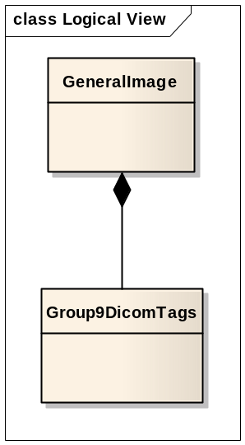

Update Database Adapter
- Update dicom.properties and DicomConstants to include entries for PHI fields.
- Alter GeneralImage domain object (in both database adapter and in NCIA web application) to include new properties.
- Alter GeneralImageOperation to include new method populateEncryptedIdentifiers() to be called from validate method at end:
private void populateEncryptedIdentifiers(Map numbers,
GeneralImage generalImage) {
String encryptedPatientId = (String)
numbers.get(DicomConstants.ENCRYPTED_PATIENT_ID);

if (encryptedPatientId != null) {
generalImage.
setEncryptedPatientId(encryptedPatientId.trim());
}

[…]
}

Retrieval Queries
The template for the retrieval query is: select encrypted_fields from general_image where hashedid field name = ?
select encrypted_accession_number,
encrypted_study_instance_uid,
encrypted_sop_instance_uid,
encrypted_series_instance_uid,
encrypted_patient_id
from general_image
where <HASHED ID FIELD NAME> = ?
“HASHED IF FIELD NAME” can be: {patient_id, sop_instance_uid, study_instance_uid, series_instance_uid}

Decryption Tool
The CTP anonymizer uses the Blowfish algorithm to encrypt/decrypt data. John Perry provided a CipherUtil object to do the decryption. A command line tool will take command line arguments (base 64 ciphertext, the key) and pass these to CipherUtil in order to generate the plaintext.
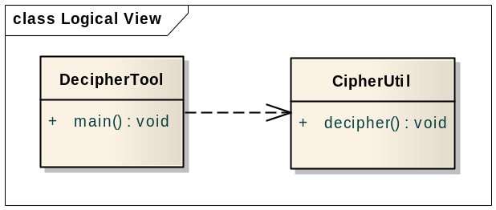

Test Approach
- Install CTP client and server with deploy:local:install
- Update anonymizer scripts in client and server
- Using FileSender, send an image.
- Using SQLyog, look in GENERAL_IMAGE and ensure that fields are filled in.
- Run the retrieval query.
- Use the DecipherTool to decrypt results and ensure it is same as input.

